

# PO1_DGC Calculator

**(Req_PO1_DGC_SWITCH_CDD)**

**Status**: **Draft**

### 

### 

### 

### 

### **Document Status**

|  |  |  |  |
| --- | --- | --- | --- |
| **Version** | **Status** | **Author** | **Date** |
| V 1.0 | Draft | May Abdelsalam | 5/3/2020 |
|  |  |  |  |

### 

### **History Table**

|  |  |  |  |
| --- | --- | --- | --- |
| **Version** | **Author** | **Date** | **Change** |
| 1.0 | May Abdelsalam | 5/3/2020 | Initial creation |
|  |  |  |  |

## **Table of contents**

1. **Project Description**
2. **APIs**
3. **Global variables**
4. **SW Context Diagram**
5. **Flow Chart**

## 

## **Index of figures**

* **APIs. .…………………………………..………………….. 4**
* **Software Context diagram: Figure 1..……………….. 5**
* **Flow chart: Figure 2..…………………………………… 6**

## 

## **Project Description**

The Digital Calculator system will consist of a Power component in the APP layer to turn all the system ON whenever the ON switch is pressed.

If the switch is pressed while the system is on, this will turn the system off.

**APIs:**

|  |  |  |  |
| --- | --- | --- | --- |
| **Req_ID** | Req_PO1_DGC_CDD_SWITCH_001 V1.0 | | |
| **Return Type** | STD_ERR | **Input arguments** | u8* Copy_u8switchStatus |
| **Name** | SWITCH_GetSwitchStatus | | |
| **Description** | Gets the status of a switch (the power switch), wither it’s pressed or not pressed | | |
| **Covers** | Req_PO1_DGC_GDD_014 V1.1 | | |
| **public/private** | Public | | |

### 

### **Global Variables**

**-N/A**

### 

### **SW Context Diagram**

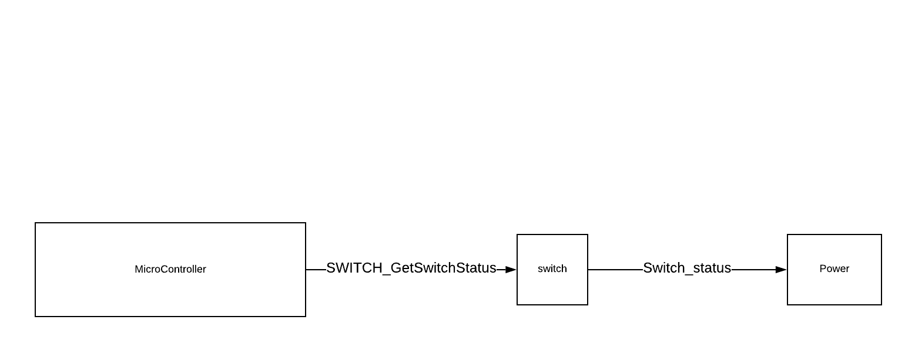

Figure 1

### **Flow Chart**

### 

Figure 2

### 

### 

### **Reference Documents**

|  |  |  |  |
| --- | --- | --- | --- |
| **Reference Number** | **Document Name** | **Version** | **Status** |
| 1 | GDD | 1.3 | proposed |